- Evidence:
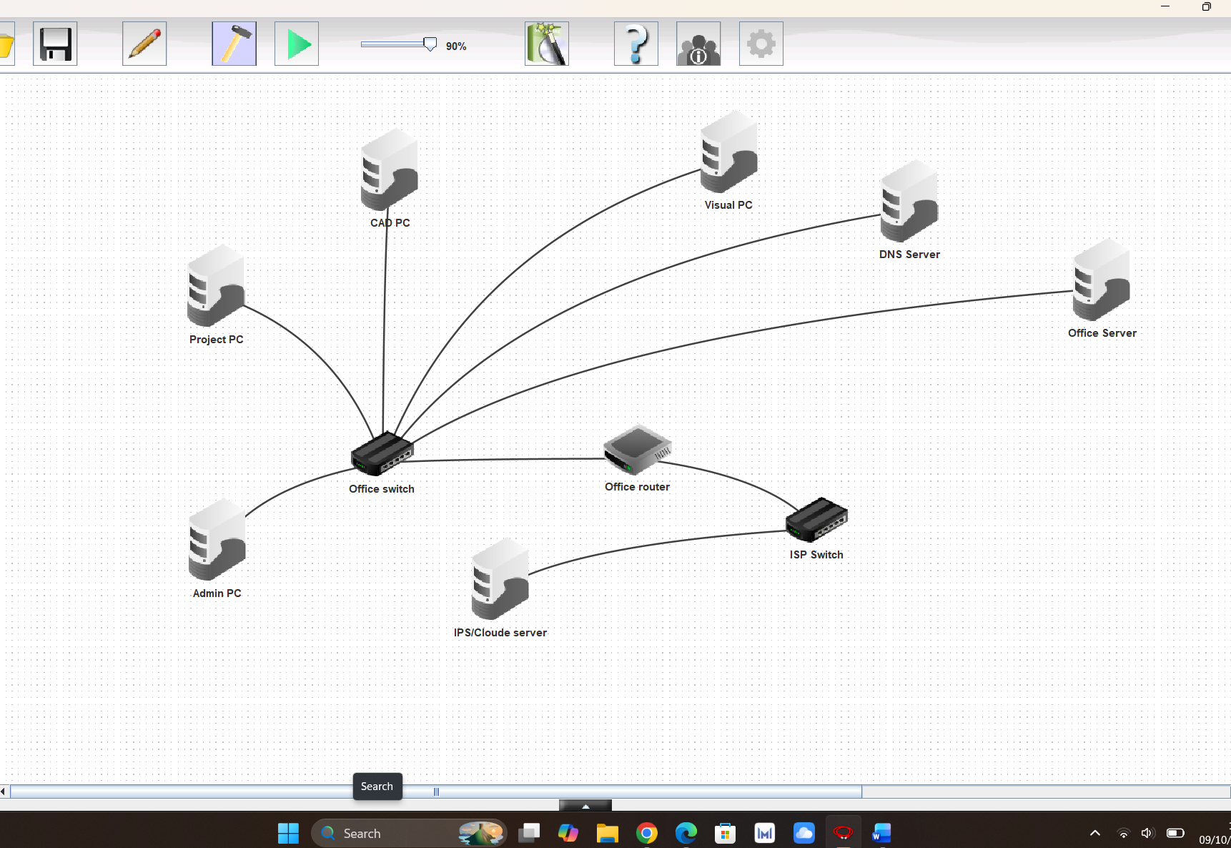

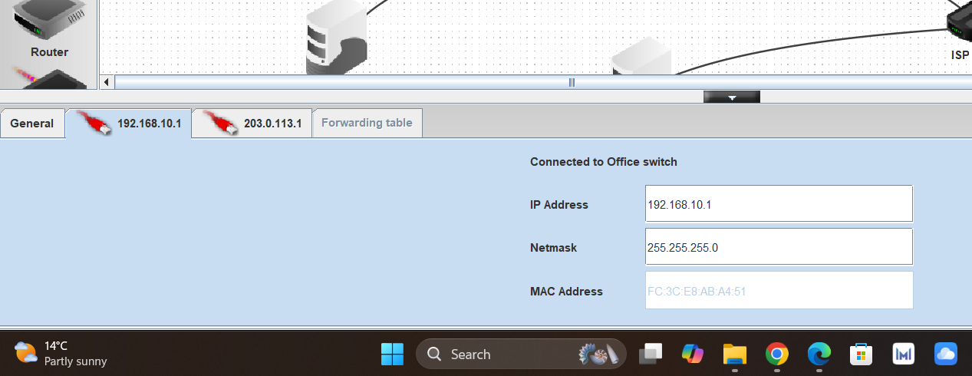
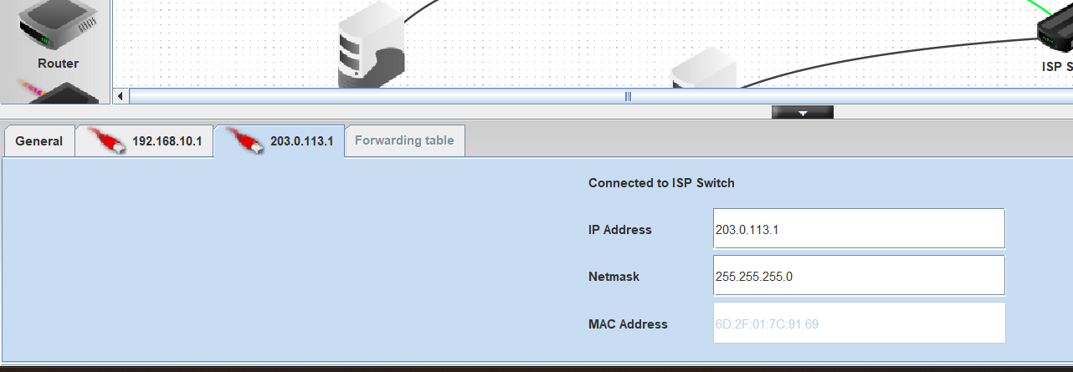
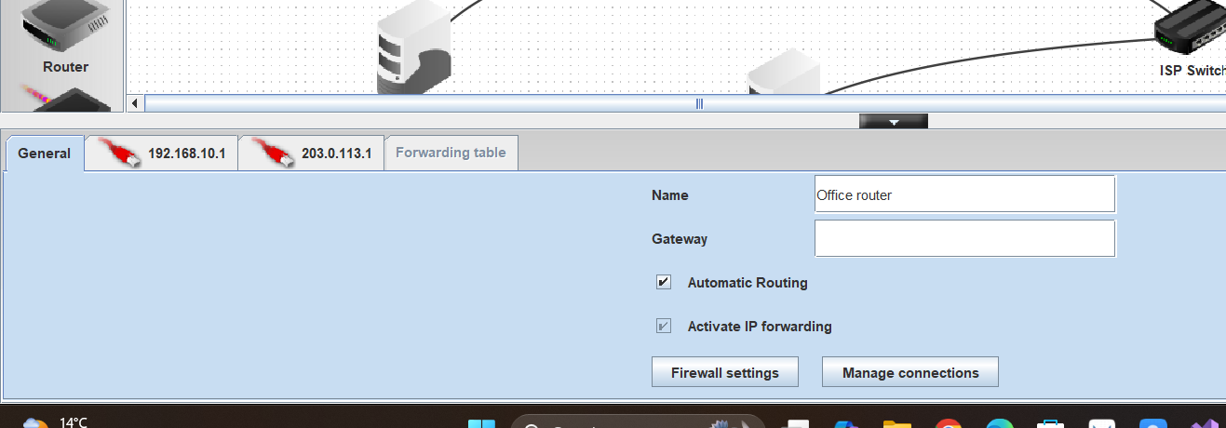

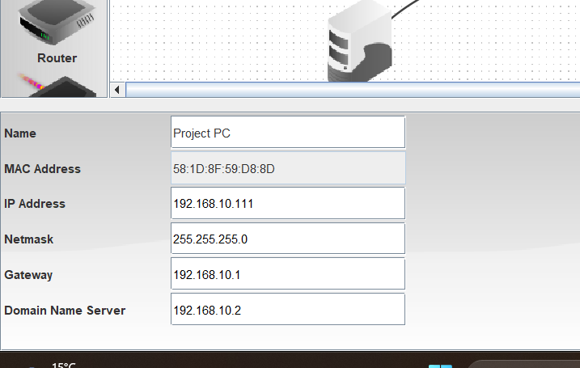
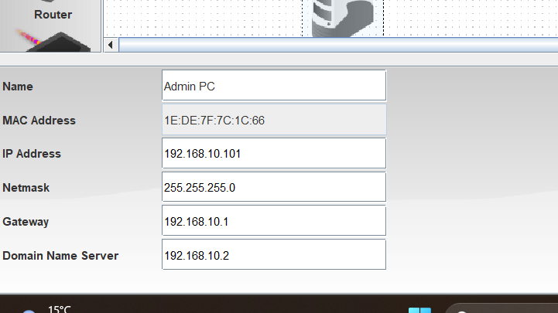
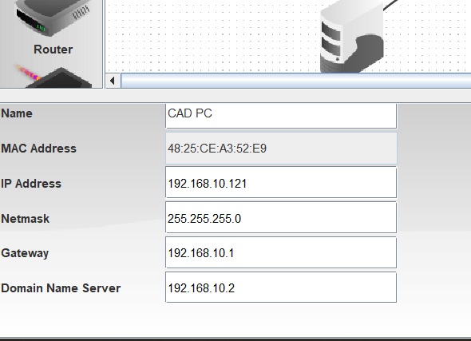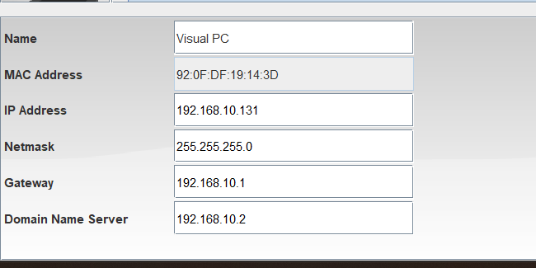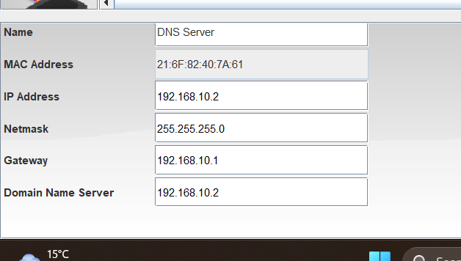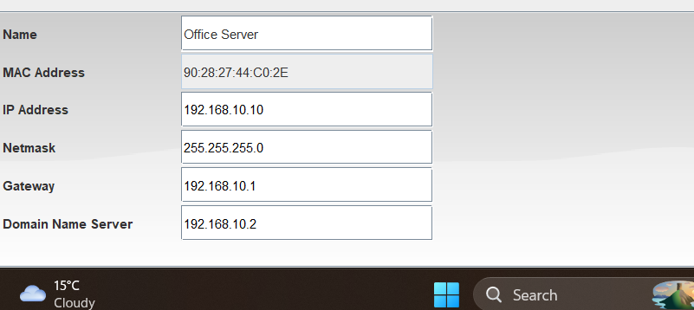
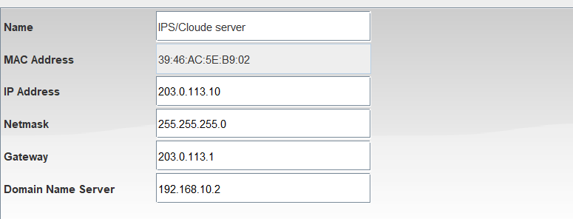
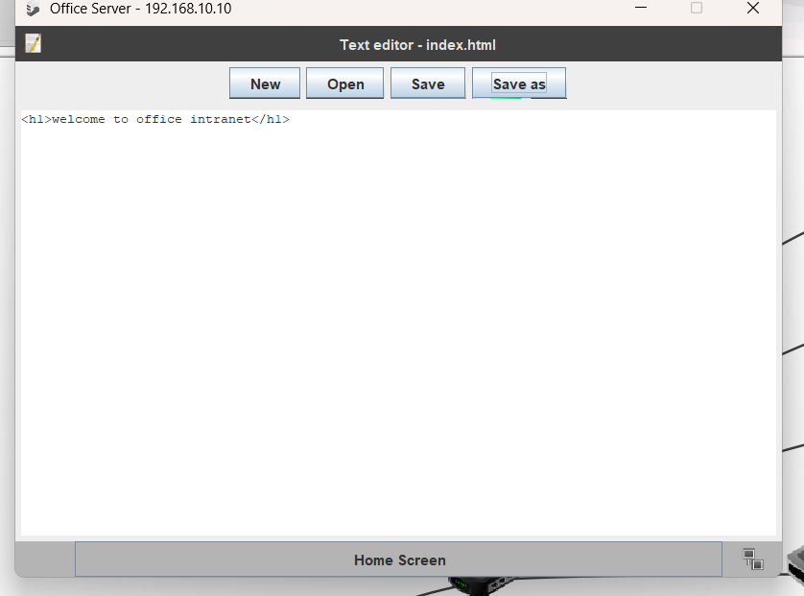
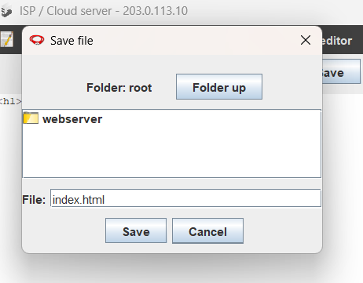
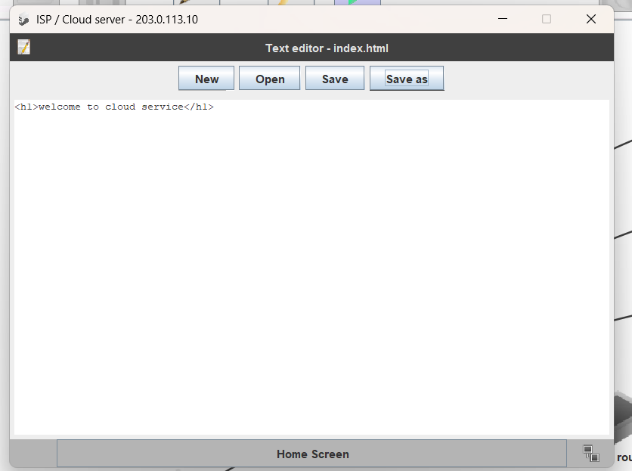
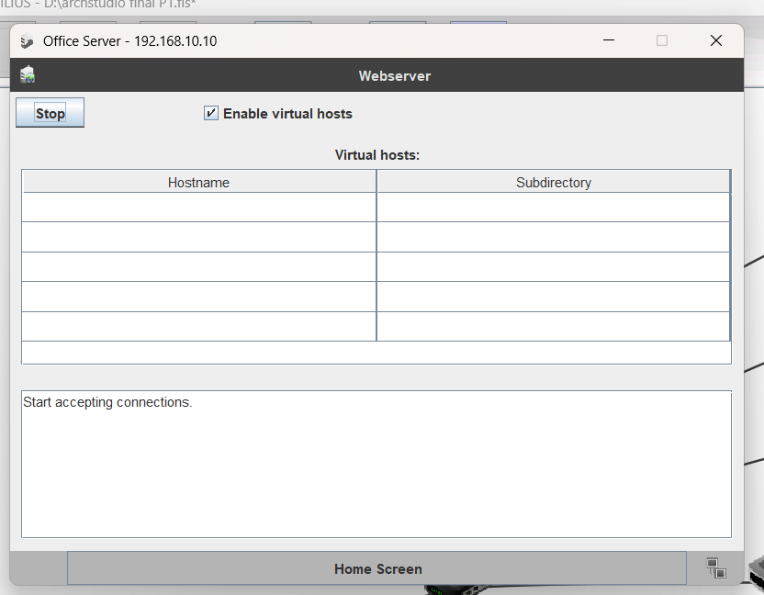
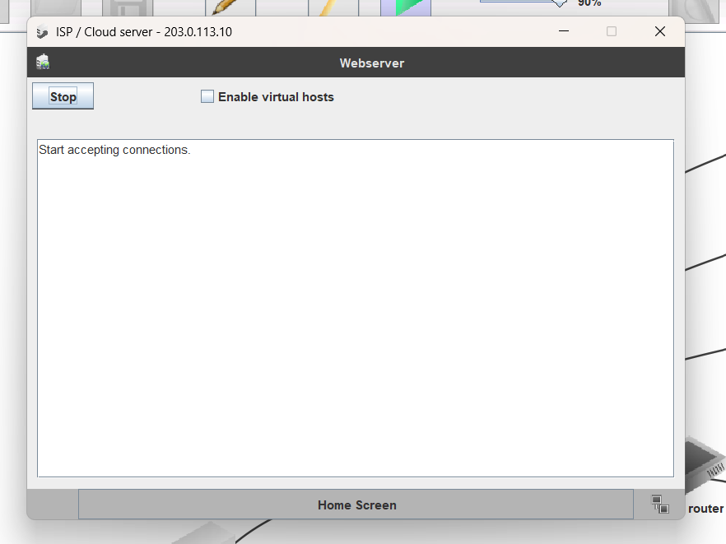
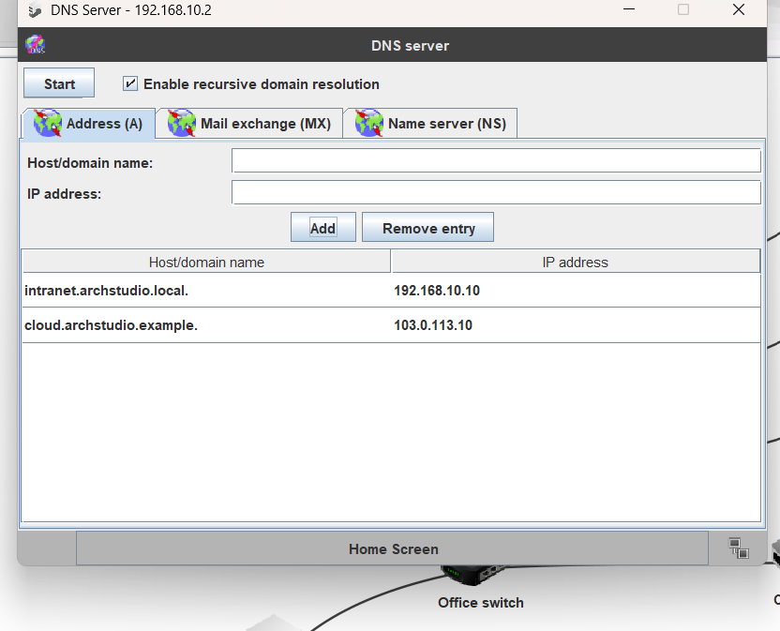
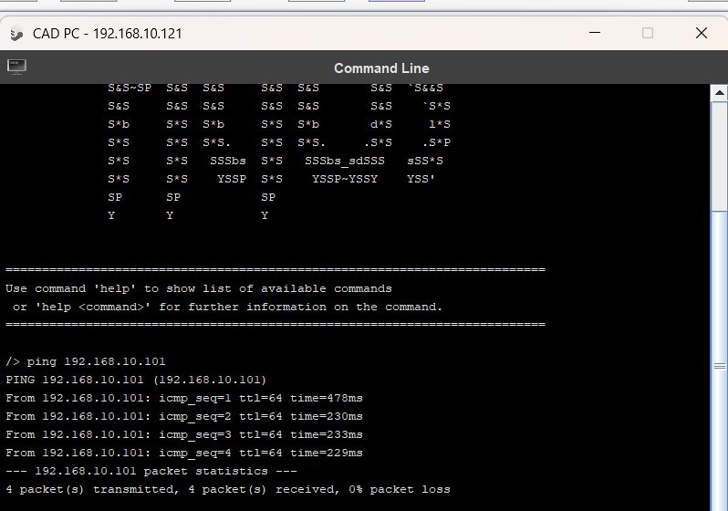
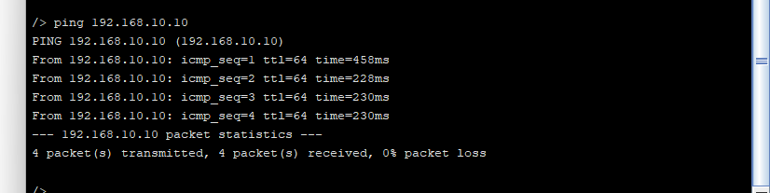
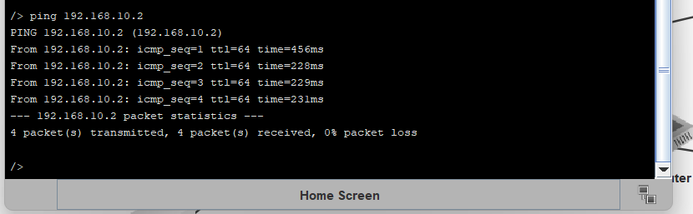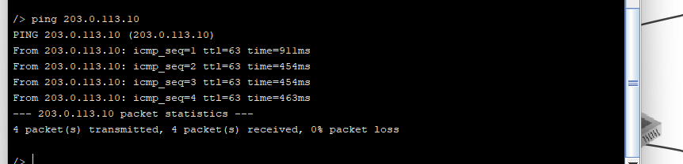

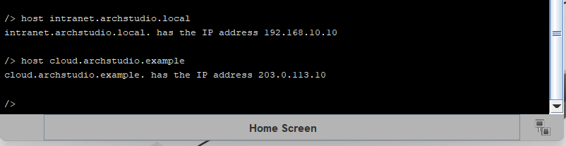
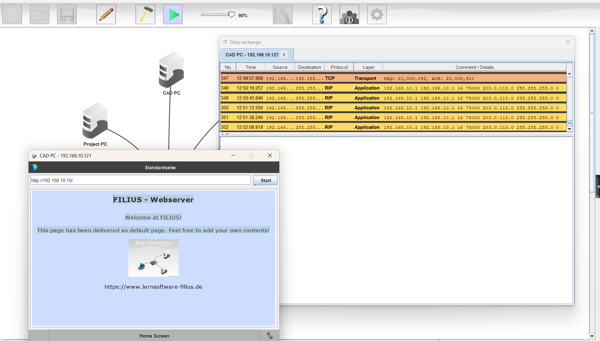
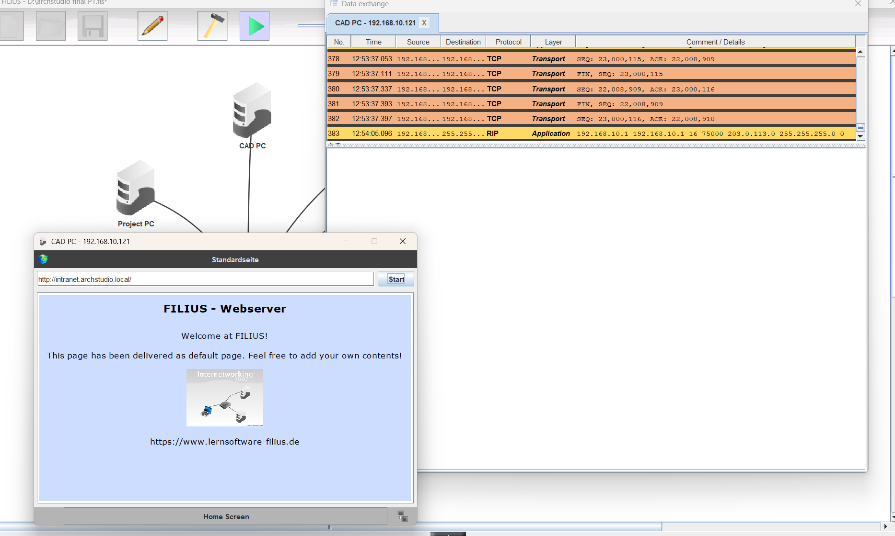
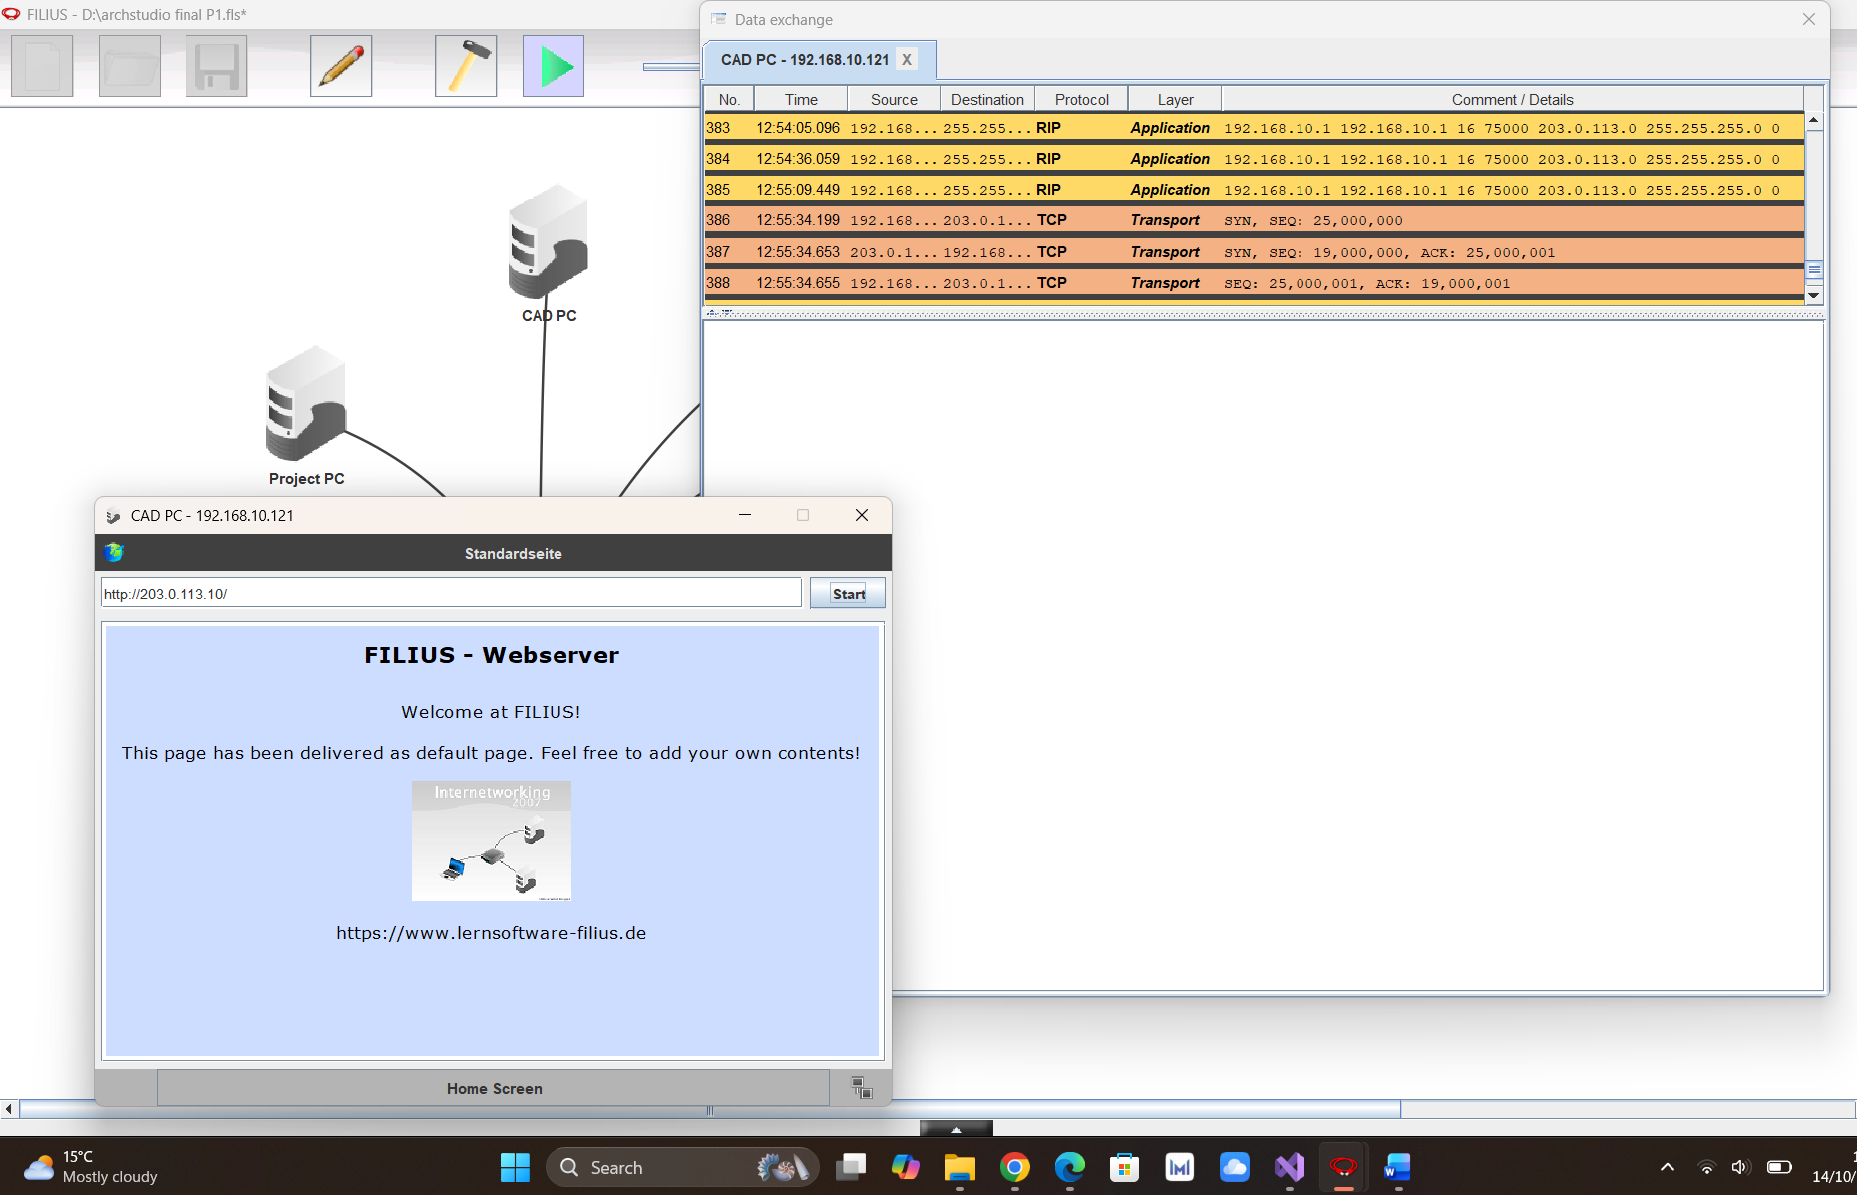
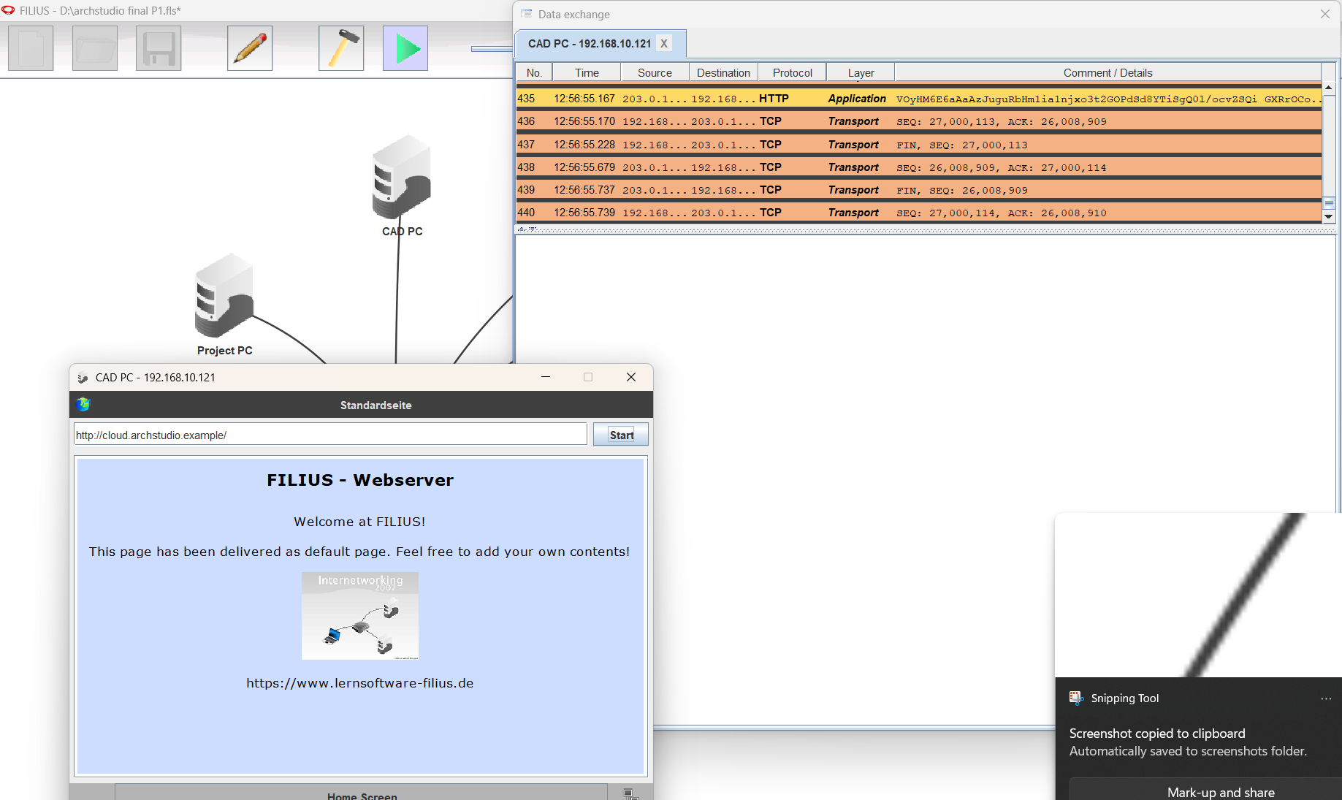

- IP Addressing Table:
Device | IP Address | Subnet Mask | Gateway | DNS
Router (Office side) | 192.168.10.1 | 255.255.255.0
Router (External side) | 203.0.113.1 | 255.255.255.0
DNS Server | 192.168.10.2 | 255.255.255.0 | 192.168.10.1 | 192.168.10.2
Office Server | 192.168.10.10 | 255.255.255.0 | 192.168.10.1 | 192.168.10.2
Admin PC | 192.168.10.101 | 255.255.255.0 | 192.168.10.1 | 192.168.10.2
Project PC | 192.168.10.111 | 255.255.255.0 | 192.168.10.1 | 192.168.10.2
CAD PC | 192.168.10.121 | 255.255.255.0 | 192.168.10.1 | 192.168.10.2
Visual PC | 192.168.10.131 | 255.255.255.0 | 192.168.10.1 | 192.168.10.2
ISP / Cloud Server | 203.0.113.10 | 255.255.255.0 | 203.0.113.1 | 192.168.10.2

- Protocols:

- TCP/IP:
Transmission Control Protocol/Internet Protocol are the rules that make all the connections and are responsible for making conversation between both local and external networks. When a computer sends data, TCP converts this data into small packets and checks that this data is safely sent and then puts it back together at the destination; on the other hand, IP checks that the data is sending to the correct address/destination.

- IP addressing and Subnet mask:
In a specific network, every PC and server has its own unique IP address. And it helps a PC to communicate with another PC. Just like every house has its own different address and every house is recognized by its different address, the network also works the same. The subnet mask is actually used to figure out which is the network number and which is the PC number in an IP address.

- Default Gateway:
Default gateway is just like a main exit door. When any office PC wants to send anything to another network or internet/cloud, then the data will go first to the default gateway. And then it sends this data to another specific network.

- DNS:
DNS works just like a phonebook. When we cannot remember all the PCs' and servers' IP addresses, then we give those addresses a proper name, and DNS converts those names into the correct IP address.

- HTTP (Hypertext Transfer Protocol):
HTTP is the way of creating a connection between a browser and a web server. Whenever you ask a browser to open any page, the browser sends a message to the server through HTTP to open that particular page. Then the server responds by sending the web page back through HTTP.

